**Elizabeth South Primary School –**

**Complaint Management in Schools and Preschools 2025**

Last updated: March 2025

This is an extract from the [complaint management policy (PDF 263KB)](https://www.education.sa.gov.au/policies/shared/complaint-management-policy.pdf) that gives an overview of information. Staff must review the full version of the complaint management policy before making a decision or action.

## **Purpose**

We recognise that sometimes things go wrong, and you may feel that your expectations are not being met. If you have an unresolved complaint or would like to provide feedback, we would like to hear from you. It’s important to work together, talk, listen and find solutions in a courteous and respectful manner, so we can improve our services.

The Department for Education (department) promotes and values feedback and works to manage complaints in order to improve performance, systems and service delivery. The department is committed to resolving complaints and providing an accessible, transparent and fair process to everyone.

All complaints will be taken seriously. When complaints are received, they will be assessed, prioritised, documented and recorded. Resolution will occur at a local level (with the original decision maker or educator) wherever possible and as quickly as possible. Most complaints are resolved quickly, but some complex matters may take more time and if this is the case, we will advise you.

## **What is a complaint**

A complaint is an expression of dissatisfaction made to or about the department relating to services, products, employees or the handling of a complaint, where a response or resolution is expected.

It’s important that the person making the complaint can talk directly to the decision maker if they are not satisfied with a decision. The staff member will make themselves available by phone or arrange a meeting time to talk about the decision and to hear the concerns.

## **Types of concerns and complaints**

You may choose to make a complaint if you believe that the school or preschool has:

* done something incorrect
* failed to do something they should do
* acted unfairly or impolitely.

Your complaint or feedback may be about:

* the type, level or quality of service
* the behaviour and decisions of staff
* a policy, procedure or practice.

Complaints and feedback may be about something we have to do because of state or federal law. In those cases, we will talk to you and help you understand the requirements and why they exist.

## **How can I make a complaint?**

The best and usually quickest way to resolve a complaint is by raising it at the school or preschool.

Find out more on the department’s website:

* [complaints about a school or preschool](https://www.education.sa.gov.au/department/feedback-and-complaints/make-complaint-about-school-or-preschool)
* [raising a complaint with the department (PDF 232KB)](https://www.education.sa.gov.au/docs/ce-office/complaints-and-feedback/raising-a-complaint-with-department-for-education.pdf) – sets out step-by-step process
* [tips to make a complaint](https://www.education.sa.gov.au/department/feedback-and-complaints/help-make-complaint/tips-make-complaint-or-give-feedback-department).

The department has a 3-level complaint management process.

## **Steps for raising your complaint**

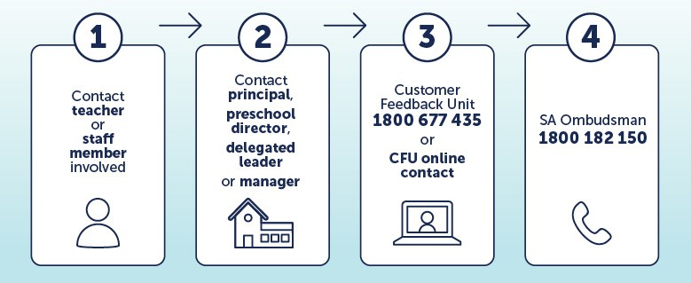

### **Level 1 – school or preschool**

If a person is not happy with a decision made or action taken by a school or preschool they should first contact the original decision maker or educator involved to discuss the matter and raise their concerns directly. This might be a teacher, year level coordinator, deputy principal, principal or preschool director.

It is expected that teachers will:

* acknowledge the complaint
* make a time available (face-to-face, by phone) as soon as reasonably possible to discuss with the parent/caregiver their complaint
* consider relevant legislation, departmental policy and guidelines, school or preschool processes, and/or seek advice from their site leader
* identify and discuss with the parent/caregiver possible courses of action that could be taken to resolve their complaint and the timeframe for this to occur
* where practicable, follow up with the parents/caregivers, after a reasonable period of time for any changes to take effect, to ensure that the parent/caregiver is satisfied with the outcome. For example, at interviews, telephone or email
* if appropriate keep a written record of the complaint, its progress and outcomes.

If you're still not satisfied that your complaint has been addressed, you can contact that person’s line manager. This might be a principal or another member of leadership. Ask to make a time to contact them to discuss your concerns. You may want to put your concerns in an email.

It's expected that when leadership handle a complaint they will:

* wherever possible, make every reasonable effort to resolve parent/caregiver concerns or complaints at the local level in a timely and effective manner
* ensure that staff are familiar with the department’s complaints policy and that school has a link to the policy
* ensure staff understand the complaint process and are aware of and have access to appropriate training
* advise all relevant parties once a complaint has been received
* consider whether the parent/caregiver may require a support person at a meeting
* ensure the complaint is documented and appropriate action determined
* recommend to the Education Director any system improvements at a broader level that may reduce the likelihood of similar complaints
* seek advice and support from the Partnerships, Schools and Preschools Division, phone 8226 1290
* refer to feedback and complaints about schools and preschools and contact Customer Feedback as required
* advise the parent/caregiver of their right to contact Customer Feedback, if a resolution at the school can't be found.

### **Level 2 – central complaint resolution**

If a person is not satisfied that their complaint has been addressed at the school or preschool level, including the principal or preschool director (or delegate), they can contact the Customer Feedback Team.

The role of Customer Feedback is to give advice and support about the issues behind a complaint and to confirm if departmental policy and procedure has been followed. Customer Feedback liaise with schools and preschools to help all parties to explore appropriate options for resolution.

A complaint or feedback can be lodged to Customer Feedback by using the [online submit a complaint form](https://schools-sa.my.site.com/CFU/s/) or by phone (free call) 1800 677 435.

### **Level 3 – external resolution**

If all avenues to resolve the complaint by the department have been exhausted and the matter remains unresolved, a review or advice can be sought through the [Ombudsman SA](http://www.ombudsman.sa.gov.au/complaints) (OSA). The OSA is an independent body that investigates complaints about SA government. Contact the OSA on (08) 8226 8699. The circumstances of the complaint will influence whether the option of an external review is available.

## **Unreasonable conduct**

Staff safety and wellbeing is vital when dealing with unreasonable conduct at a school or preschool. There’s a need to balance the right for someone to make a complaint with the rights of staff safety and respect, and the rights of others to equal time and resources.

There are a number of actions that can be taken by the school or preschool if a person making a complaint is unreasonable.

Unreasonable may include:

* constant phone calls, visits or emails to staff
* swearing, yelling, intimidation or offensive remarks
* making demands to staff on how the complaint should be managed.

Depending on the severity and frequency of the behaviours, actions can range from changing or limiting access to staff, students and school premises through to involving police. You can find out more about unreasonable conduct when making a complaint in appendix 4 of the [complaint management policy (PDF 263KB)](https://www.education.sa.gov.au/policies/shared/complaint-management-policy.pdf).

## **Our commitment**

We know that when we can work together, things can be better. We are committed to a resolution; we have experience in getting things right and we want the opportunity to resolve issues in a fair and timely manner. Be assured, we take customer feedback and complaints seriously.

## **Supporting information**

* Elizabeth South Primary School Learning Code
* behaviour support policy
* school anti-bullying policy.